Experiment 8
Cyclomatic Complexity of a Flow Graph using RAPTOR
Aim
To draw a flowchart, identify its decision points, and calculate its cyclomatic complexity.
Procedure
- Open RAPTOR and create a new flowchart.
- Add an Input symbol to read a number n.
- Add a Selection symbol with the condition n > 0.
- On the Yes branch, display Positive.
- On the No branch, display Not positive.
- Connect both branches to the End symbol.
- Run the flowchart and test it with different input values.
Output
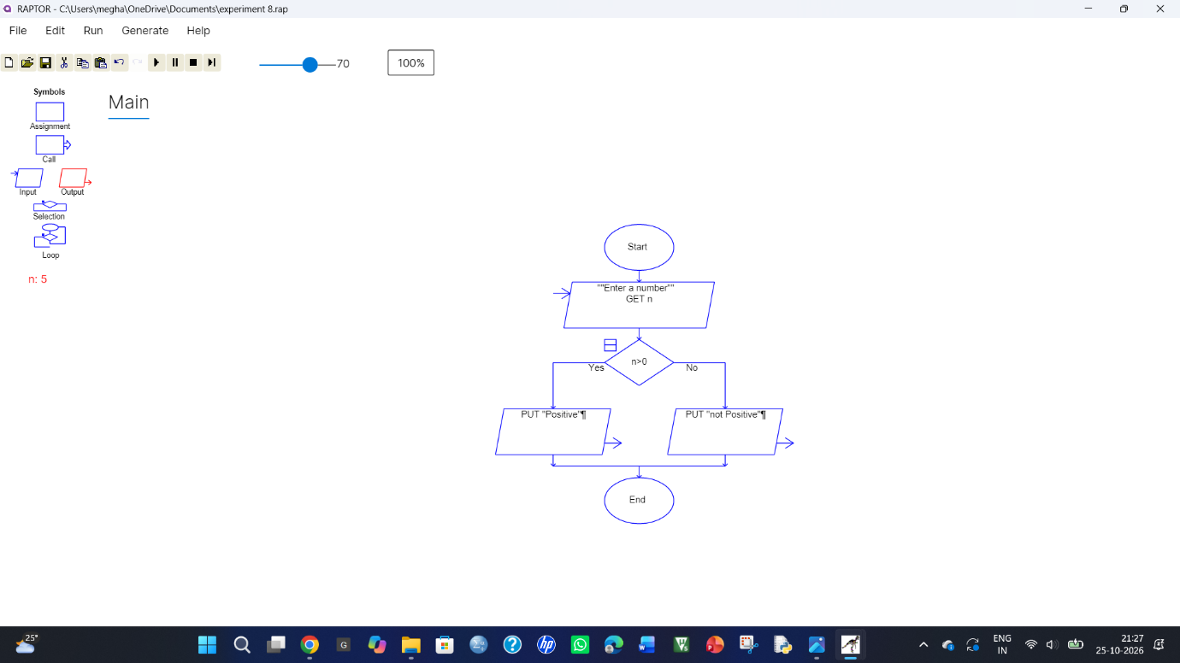
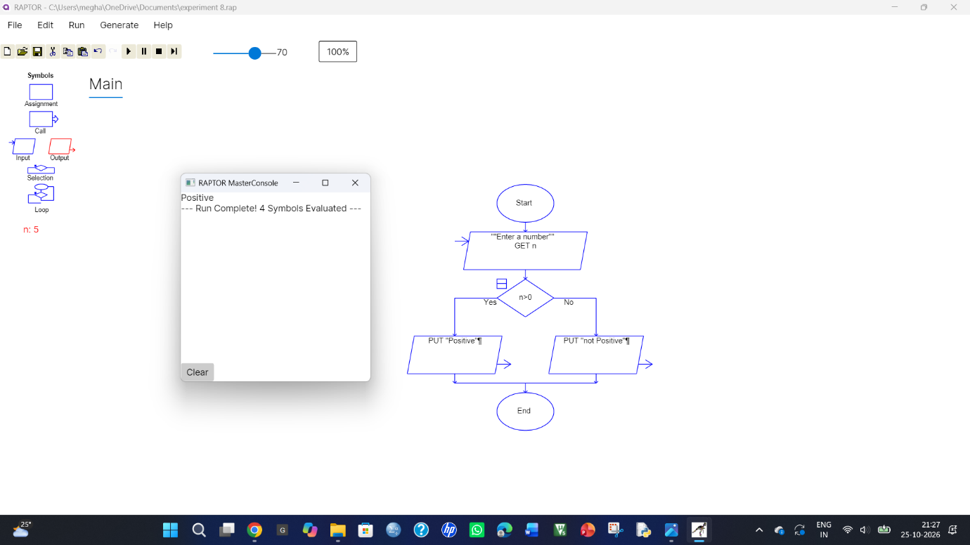
Cyclomatic Complexity:
- Number of decision nodes = 1
- V(G) = 1 + 1 = 2

Result
The flowchart was created and tested successfully in RAPTOR. The cyclomatic complexity of the flow graph is 2.

